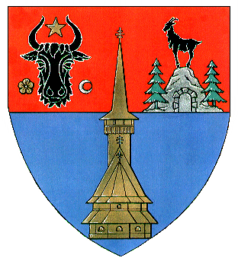


Mineralogy Museum Baia Mare Maramureş County Council
Planetarium Baia Mare www.maramures.ro
www.muzeuminbm.ro

Ref.: HUSKROUA/1101/105
Title: “pl@NETour - Creation of a scientific tourism product and infrastructure for cross-border scientific tourism network in Maramures and Transcarpathia regions"

KICK-OFF MEETING AGENDA
25 TH - 26TH NOVEMBER 2013

Location: Planetarium Baia Mare, George Cosbuc street no. 16, Baia Mare Maramures, ROMANIA,
Tel/Fax: +40 262-275206, http://www.planetariubm.ro

25-th November 2013
16.00 Arrivals of participants, accommodation at Rivulus Hotel
17.00 Visit of Planetarium Baia Mare and presentation of the main projects
implemented by Planetarium Baia Mare
Speaker: Mircea Lite, project implementation expert
18.00 Sky Presentation in the Planetarium dome
Speaker: Ovidiu Ignat, Head of Planetarium Department and technical manager

26-th November 2013
10.30 | Arrivals of the participants, registration and refreshments
11.00 | General overview of pl@NETour Project, Plan of Activities and next steps
 | Speaker: Mihaela Lite, general project manager
11.30 | Promotion and publicity activities
 | Speaker: Noemi Ganea, general project manager assistant
11.45 | Financial issues
 | Speaker: Sanda Mora, financial manager
12.15 | Group discussions and closing of the kick-off meeting
13.30 | Lunch, catering

